Kamen McPhail
CS255 Project 2
04/26/2025

CS 255 System Design Document Template

UML Diagrams

UML Use Case Diagram
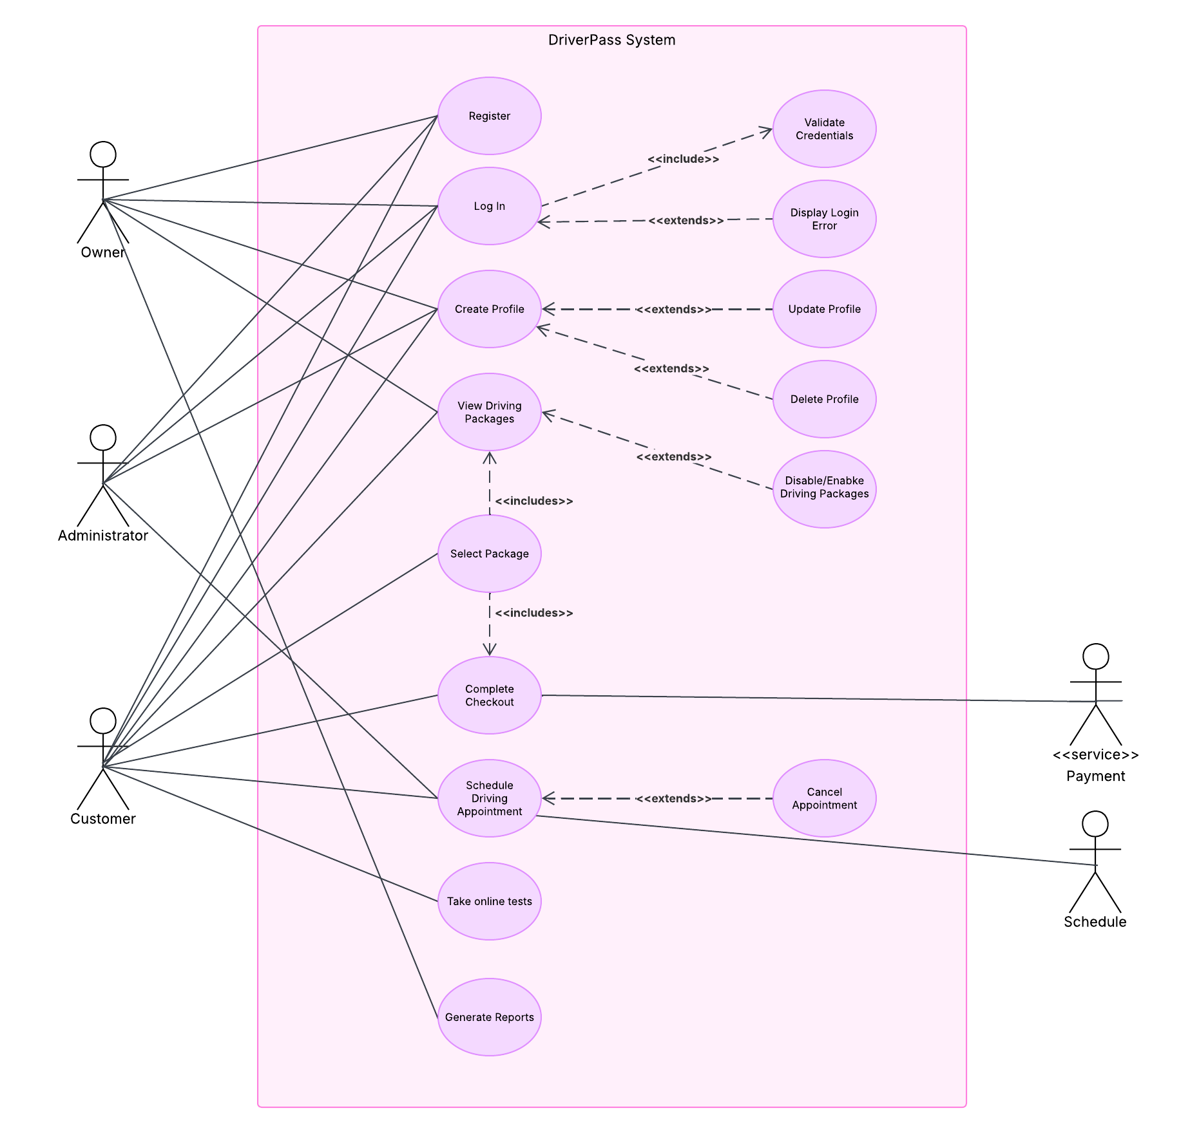

UML Activity Diagrams

Log In Use Case Activity Diagram:
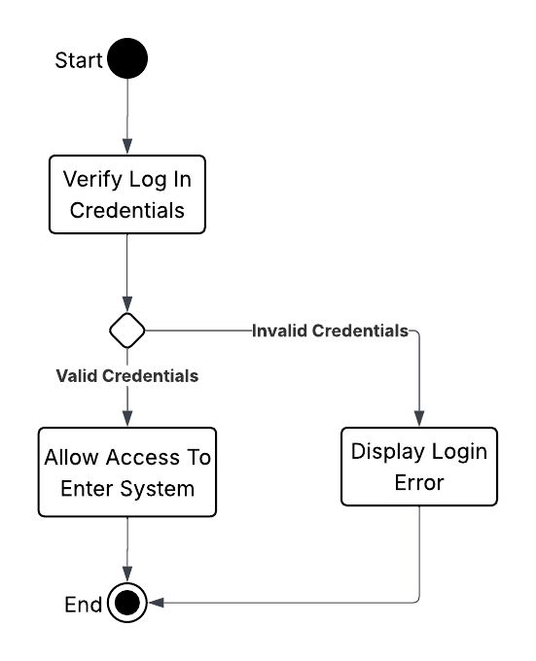
Scheduling Appointment Use Case Activity Diagram: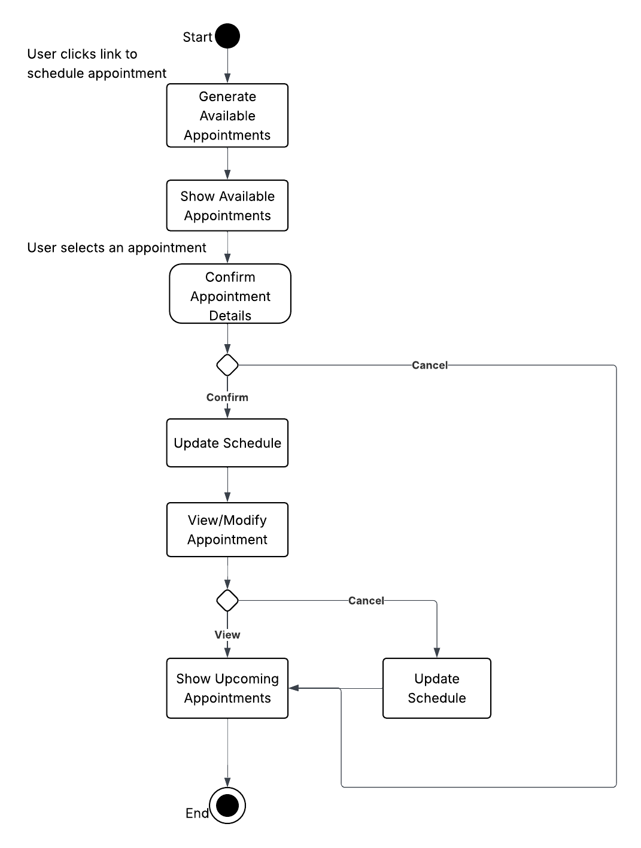

UML Sequence Diagram

Scheduling Use Case Sequence Diagram:
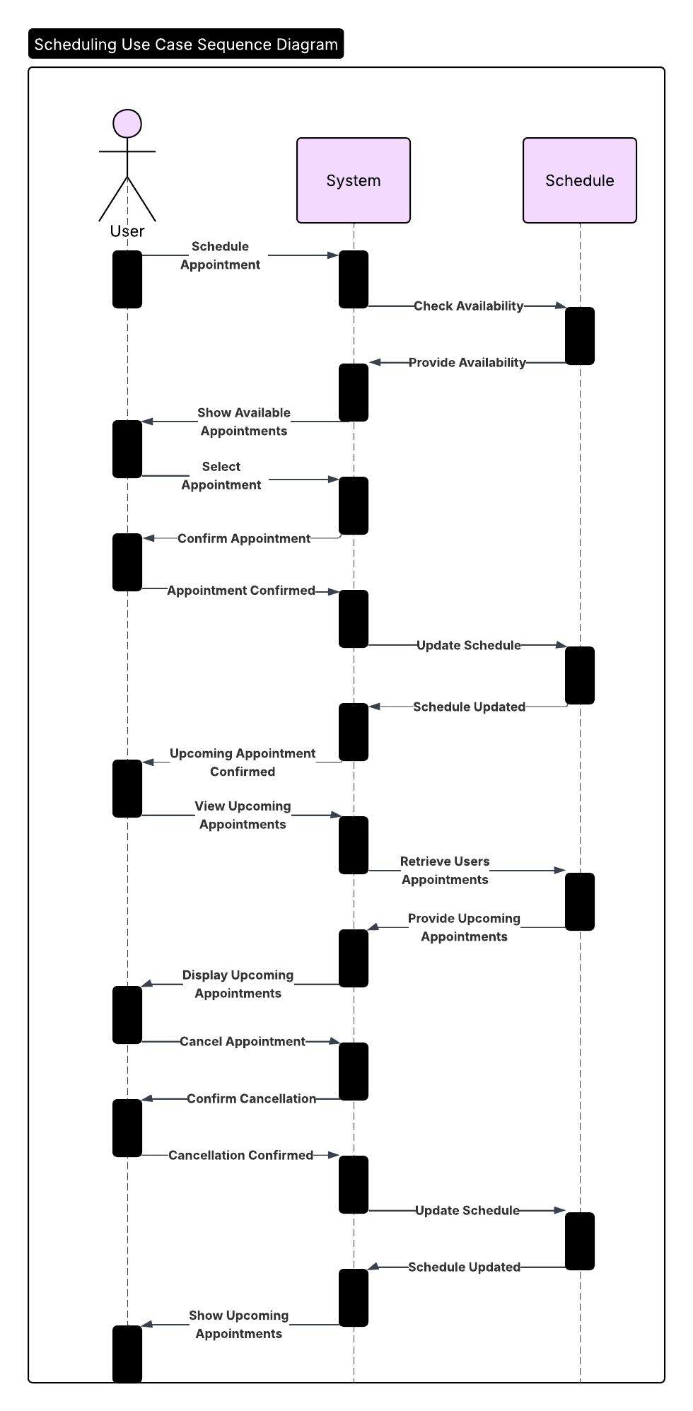

UML Class Diagram
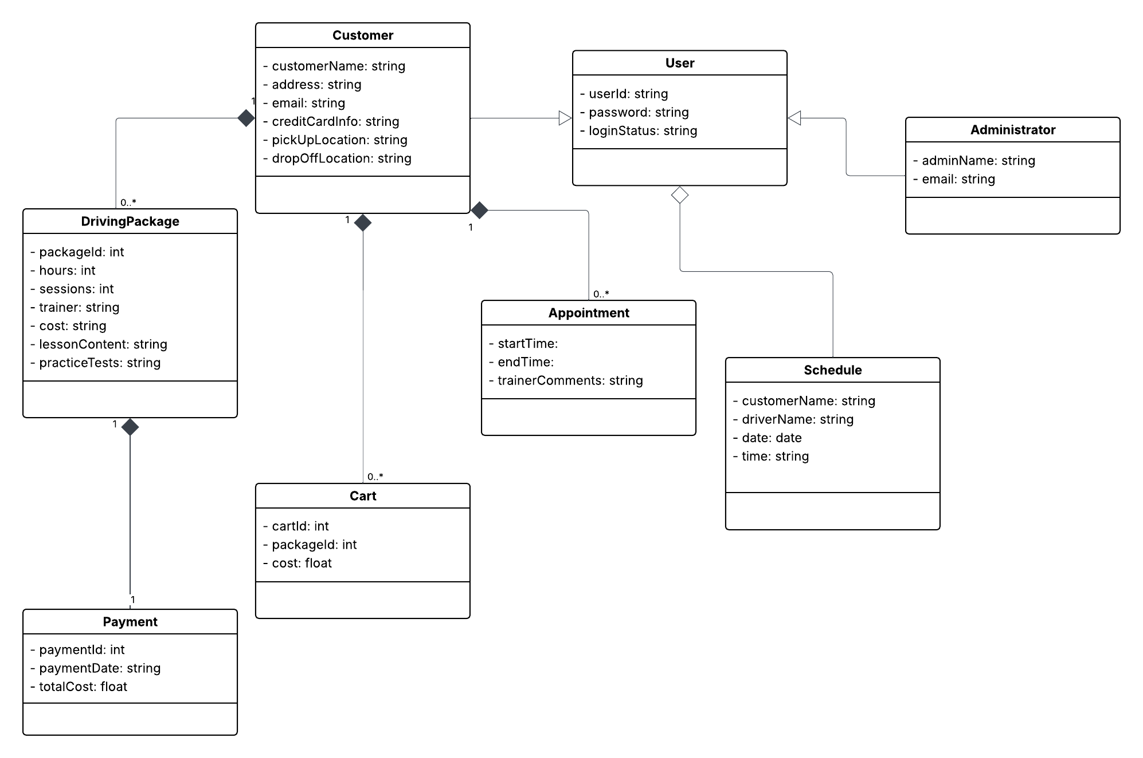

Technical Requirements
- The system will require backend tools such as databases that contain customer, employee, and car information.
- The system will run in a web-based cloud environment.
- The system will require scheduling software or a tool to keep up with real-time updates to the schedule.
- The system will need to be integrated with a secure payment service.

